Renju lesson on July 5, 2001

Hello all! Welcome to Online Renju Class. As we discussed before, we will not study the newer 12th move before WC. Therefore the lessons in July will be practicing time. We will practice the learnt material by playing the games on basis of the d11 opening. It will be the team of students versus teacher, like before. We play from the start. Now there are 21 registered students in room. So, whenever 11 votes are gathered for one move, then that move should be submitted immediately in order to save time.
Tricky 4th move seems to cause some excitement here. But you all know the right 5th moves, you are all very careful. :)
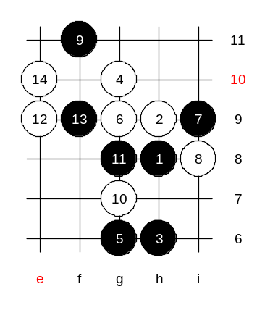
Something new perhaps? Here I go with the new 12th move. This game will hopefully give you some ideas for that 12th move, too.
You chose 13-f9. If I remember right, Nakamura played 13-d9 here, whereas my analysis proves some problems about 13-d9 and therefore 13-e10 is shown in my personal analysis. You asked, what is the problem of 13-d9. I better not announce it now, because perhaps my analysis will be useful against Nakamura or other Japanese players in the tournaments in the future.
There are 14 stones on the board now. It is a critical moment for black. Black has to decide whether to attack straight, develop or defend. Therefore do not hurry now. Better try to discuss a little instead.
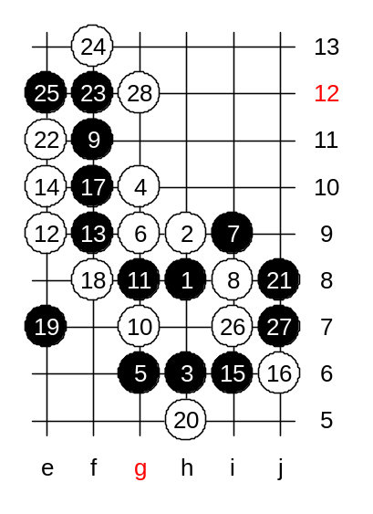
17th move – tight voting. You almost voted f7, that would have given me easy win (k6, f8). Finally you chose f10 in last moment with minimal majority of votes.
Move 19-e7 is a good move, I think.

Very balanced game.
I think, it is good time to take a break, and continue game after 7 days. I will let you have your turn in this game, so you can think of next move during the week.
May you have success in this game!

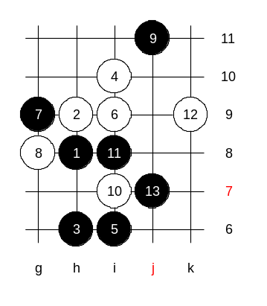

Medium level homework.
Please find the white win.

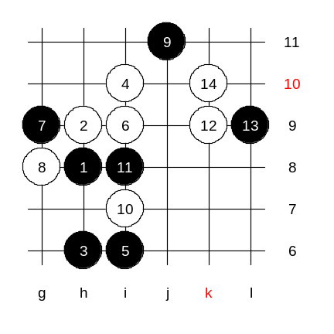

Advanced level homework.
Please find the black win.

